Maaisa reality website
- Please refer to LODHA Website .
- Home and about Page & contact us needs to be changed not able to view the content.

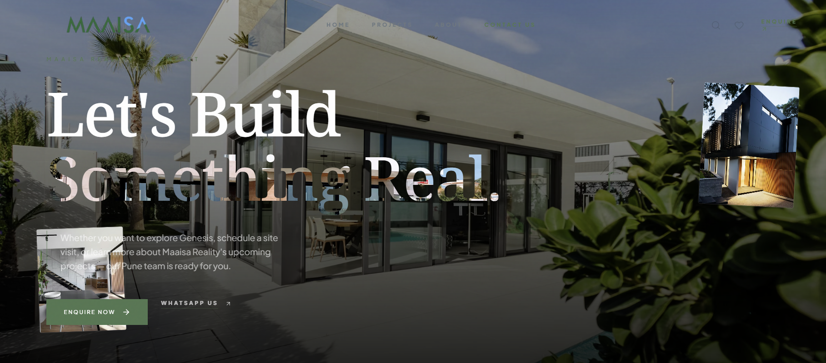

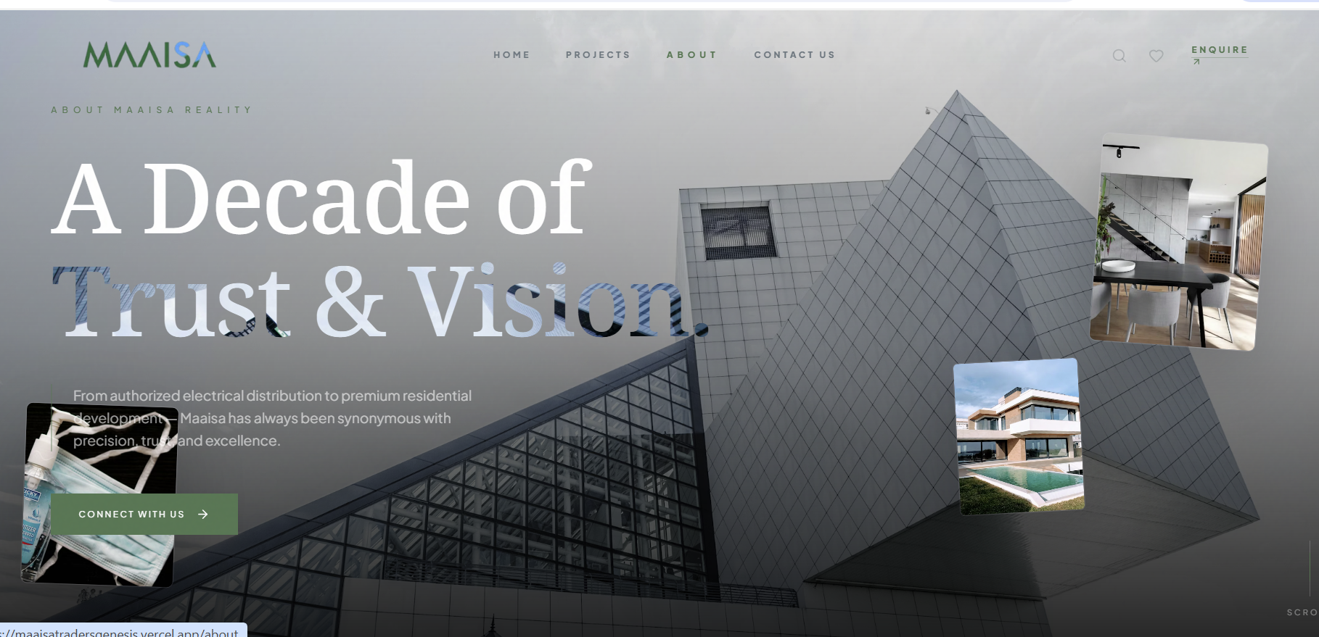

Connect Spelling .
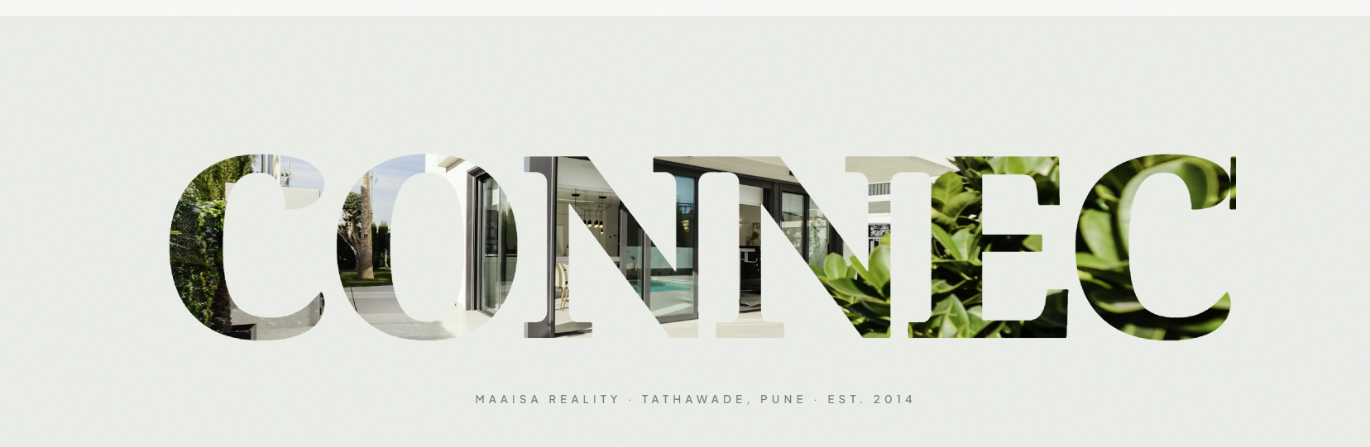

Use Images of High rise building instead of villa and bungalows.

